Project part 2

Currently the app creates its 200 customer base by having its 5 initial customers queue in the atm lines then having between 0 and 2 customers show up every second until all 200 of its customers came for the day.

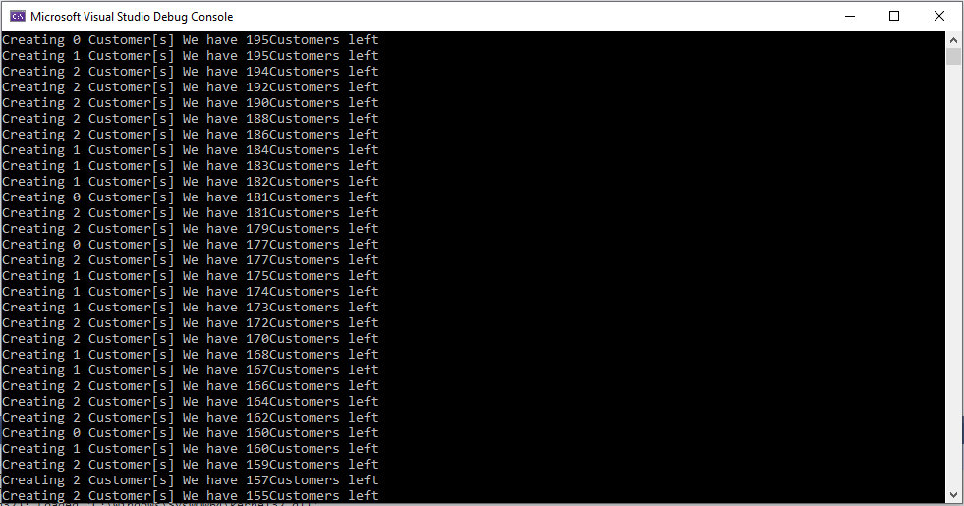

I then inspect 3 random customers to make sure they have their own accounts and ID’s some should have multiple accounts and some should only have 1. They also should all have their own individual service times and customer id’s

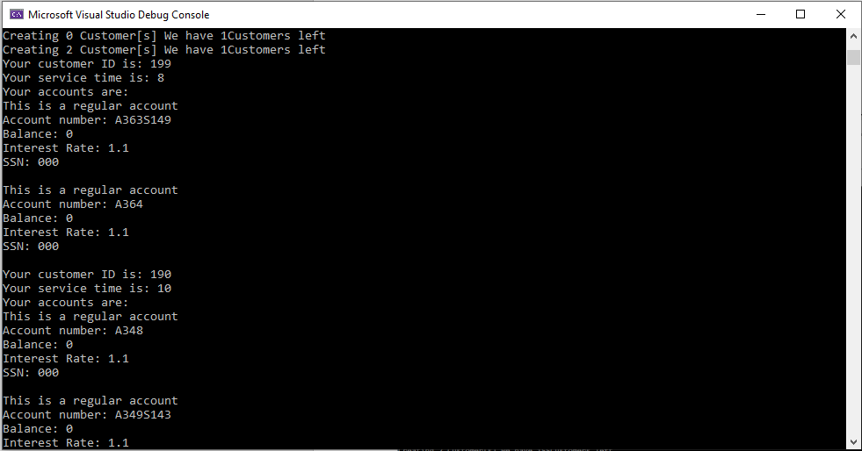

Lastly I use the statistics keeper at the bank to report the amount of ATM’s available and how long the bank was open.

